We are not in Kansas anymore.

What is the largest string?

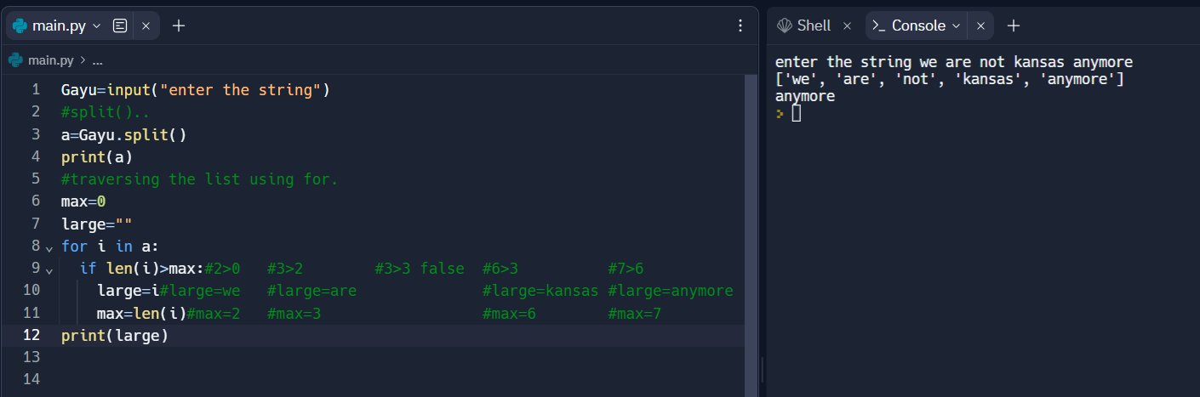

Write a program to change the string to uppercase?

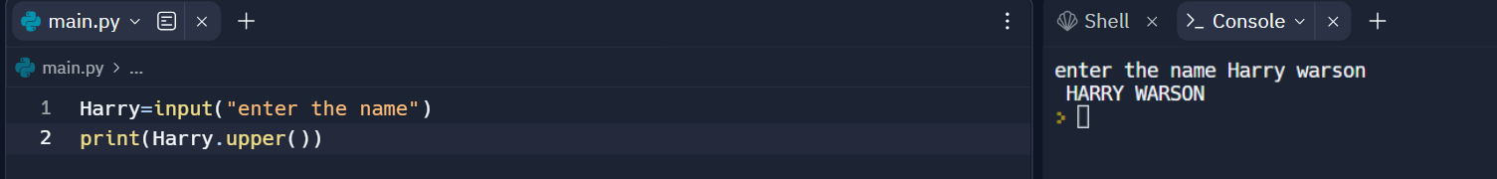

Get Ascii value:

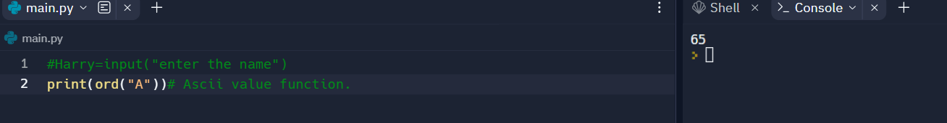

Vowel print;

